|  |  |  |  |  |  |
| --- | --- | --- | --- | --- | --- |
| Date | 24-Nov-22 | | | Tester Name | Mayuri Patel |
| Environment | Penfax - Test | | | Login used |  |
| Operating System | Select OS | Version: | Update: | | |
| Software Used | Select Software | Version: | Update: | | |
| Select Software | Version: | Update: | | |
| Release version | 22.4.1 | | | | |
| Title |  | | | | |
| Test Type | Regression | | | | |
| Test Scenario | Add a primary MEPP Beneficiary | | | | |
|  |  | | | | |
| Expected Results |  | | | | |
| Pass/Fail | Pass | | | JIRA# | N/A |

Describe your steps with screenshots:

Search for any MEPP member that do not have beneficiary listed yet.

Open that member profile.

Under person profile, beneficiary tab🡪beneficiary Designations

Add beneficiary Designation

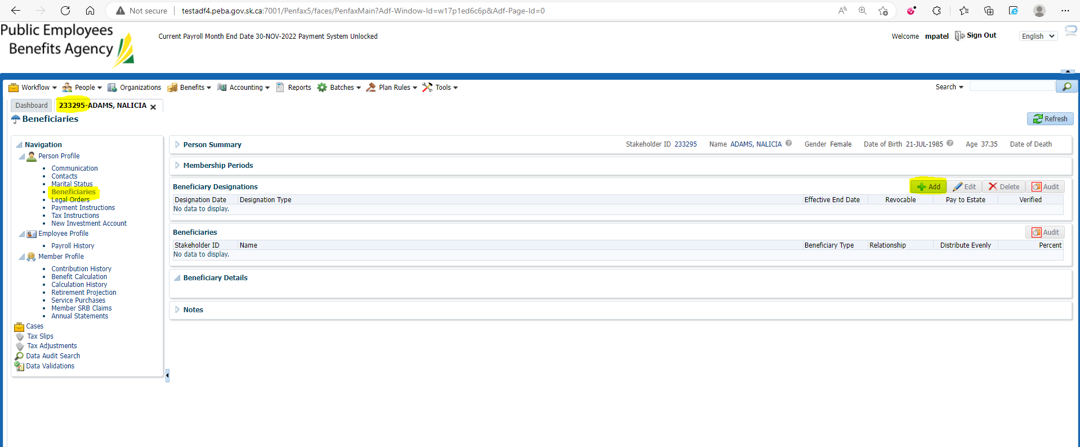

Add beneficiary details or search for beneficiary

Here, new beneficiary details are added and then save the details.

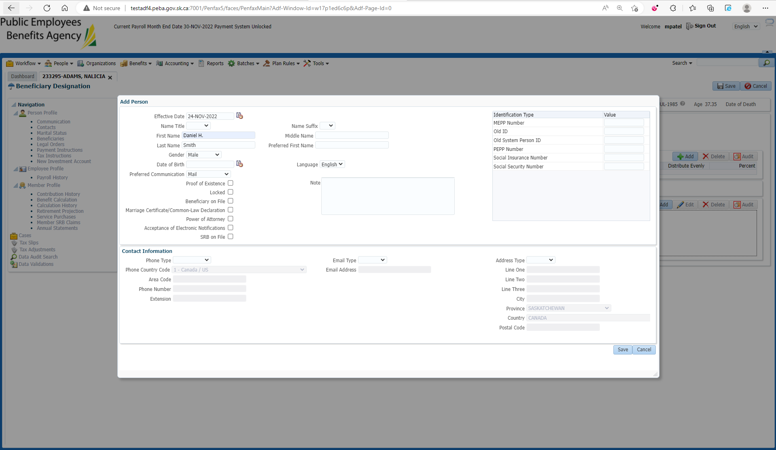

Add Beneficiary Type🡪 Primary, Relationship and percent Amount and then save the details.

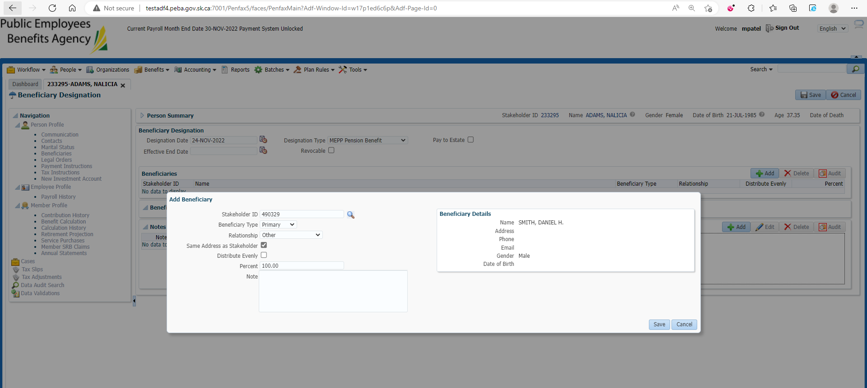

Enter Designation Date, Designation Type and hit save button at the top right corner.

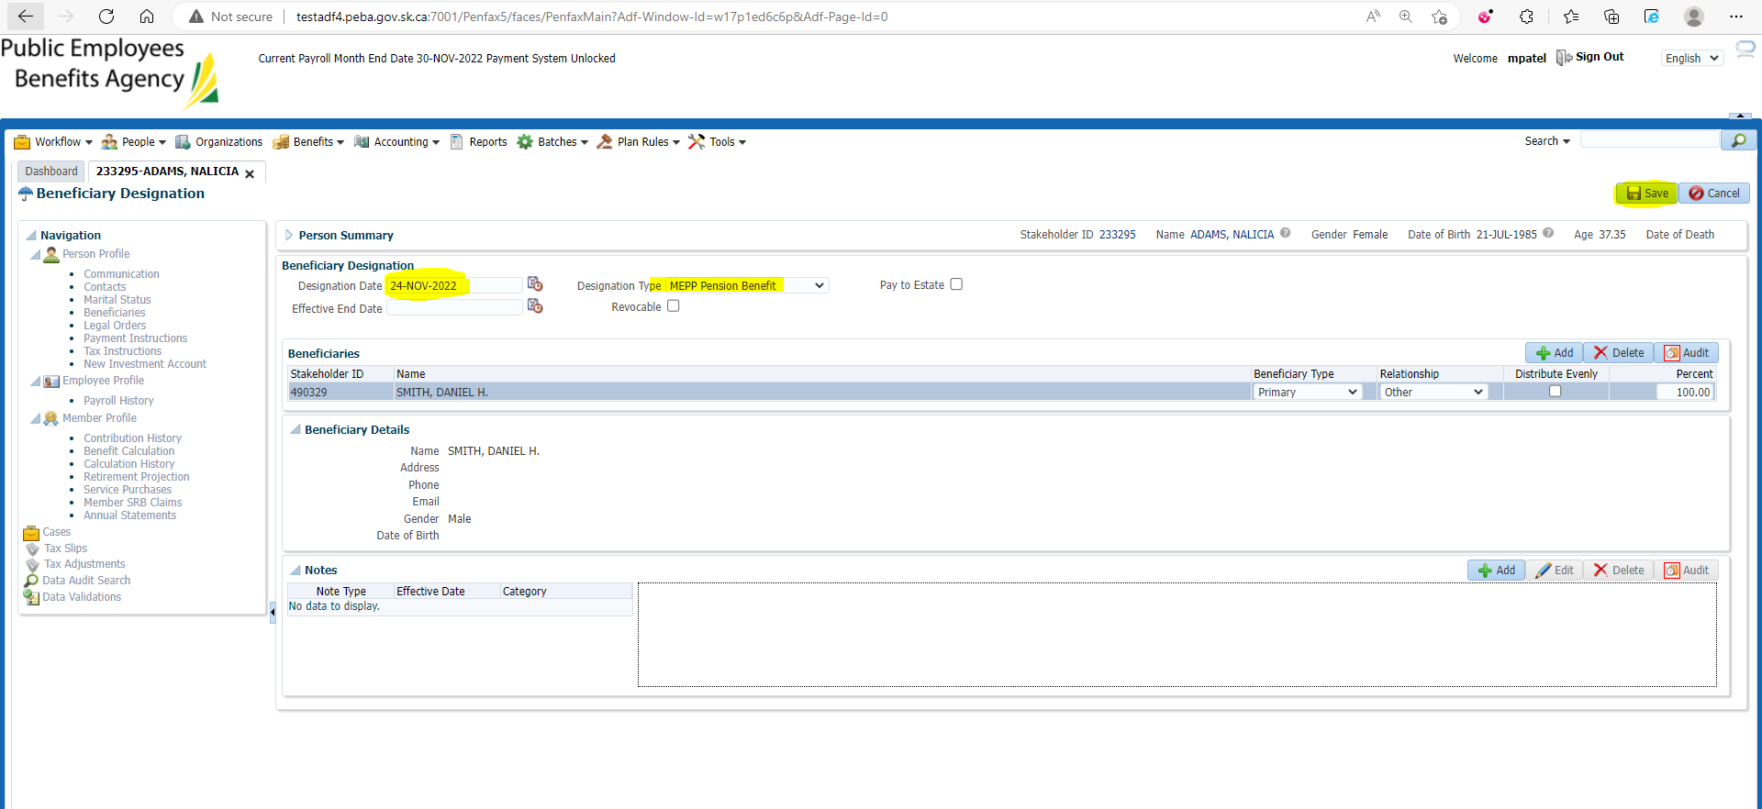

New Primary beneficiary is added

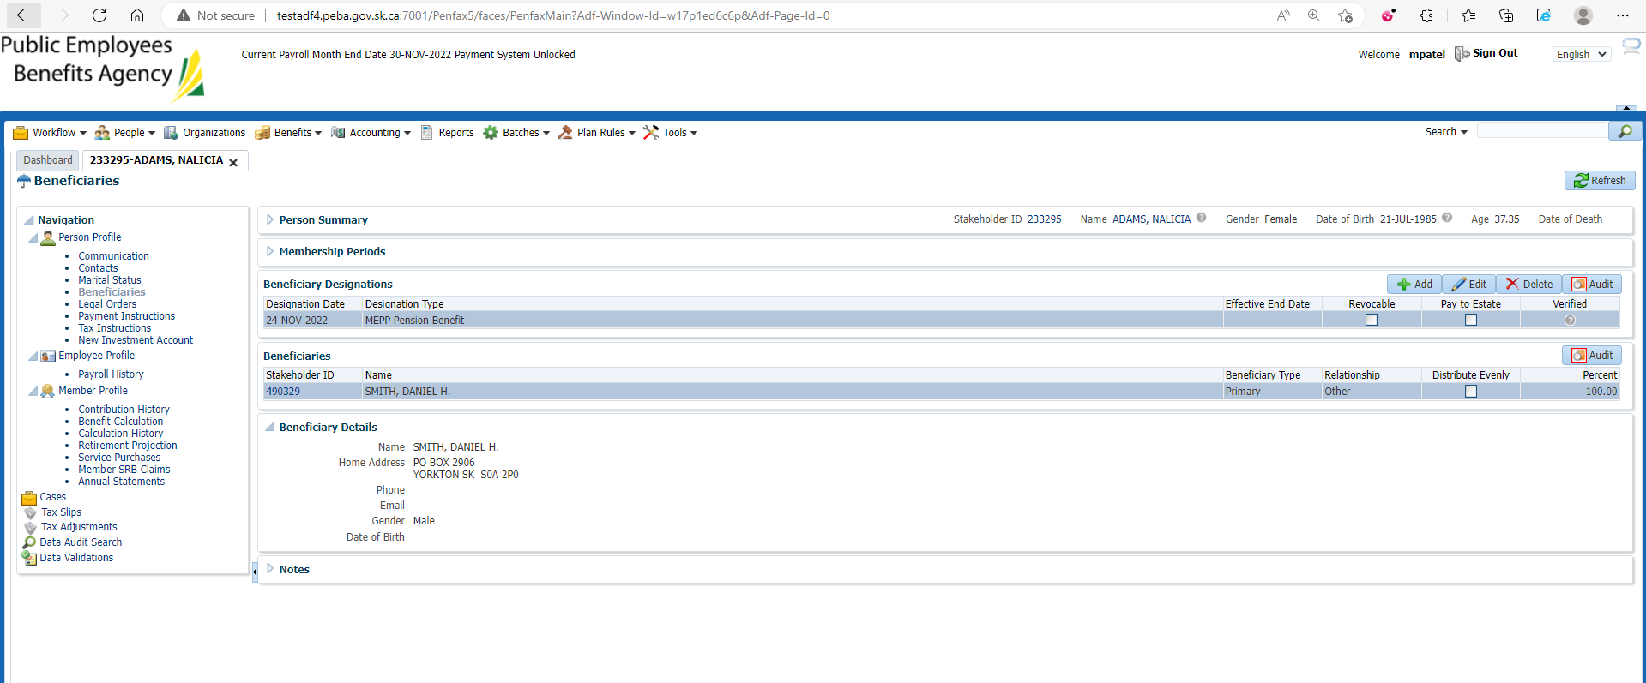

Changes are reflected in Pen web

